Nama : narendra dirga pratama

Kelas: XI RPL

Laporan Latihan sql

Kartu player esports

* Anggota player
* Gaji player
* Kartu player
* Kontrak player

Tugas 1 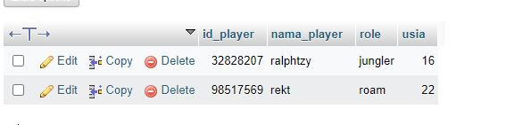

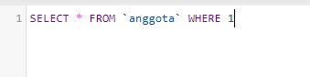

Tugas 2

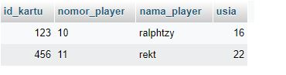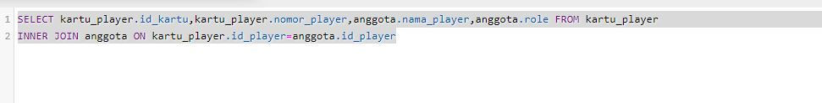

Tugas 3

